**Library management system**

*Submitted by: 1) Kadhane Sonali*

*2) Badhekar Aditya*

**INDEX:**

|  |  |
| --- | --- |
| **Page No.** | Name |
| 1. | **Introduction** |
| **2.** | **Key observation** |
| **3.** | **ER Diagram** |
| **4.** | **Conclusion** |
| **5.** | **Future Scope** |
| **6.** | **References** |

Introduction:

A Library Management System is a software application that simplifies and automates the operations of libraries.

It is a complete system for managing library duties such as purchases, member management, monitoring, storing, and circulation.

The primary objective of an Library Management System is to properly organize and manage the resources available in a library, making it easier for librarians to conduct everyday operations and create a user-friendly experience for users.

The purpose of the library management system is to automate and digitize this traditional way of managing the library work.

The Library Management System is much more user-friendly, faster in operation and easy to manage than the manual one.

Key Observation :

1. **User Roles and Permissions**: Identify different user roles within the system, such as librarians, administrators, and borrowers. Define their permissions and access levels accordingly.
2. **Catalog Management**: Efficiently manage the library's catalog, including books, periodicals, multimedia items, and other materials. Implement features for adding, updating, and removing items from the catalog.
3. **User Management and Authentication**: Implement user authentication and authorization mechanisms to ensure secure access to the system. Manage user accounts, including registration, login, and profile management.
4. **Transaction History**: Keep a record of all transactions, including borrowings, returns, reservations, and renewals. Provide users with access to their transaction history for reference.
5. **Notifications**: Send notifications to users for overdue items, reservation pickups, system updates, etc. Utilize email, SMS, or in-app notifications based on user preferences.

1) ER Diagram:

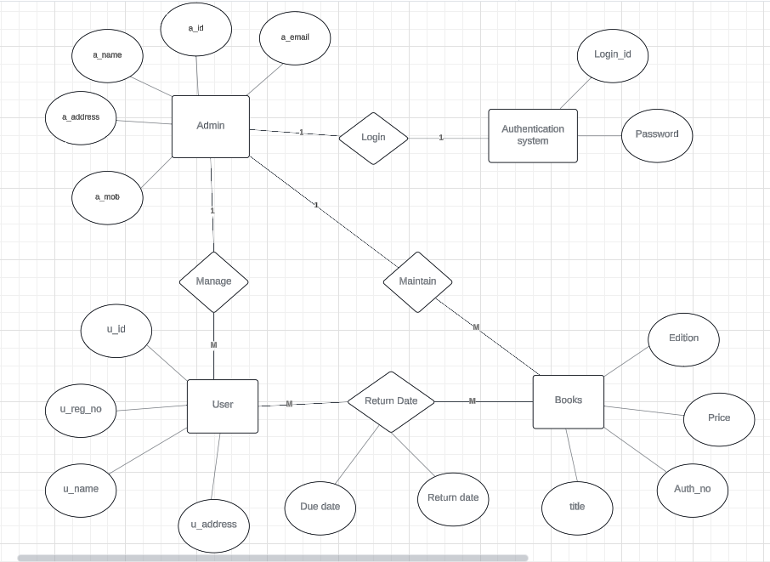

2) Data Flow Diagram:

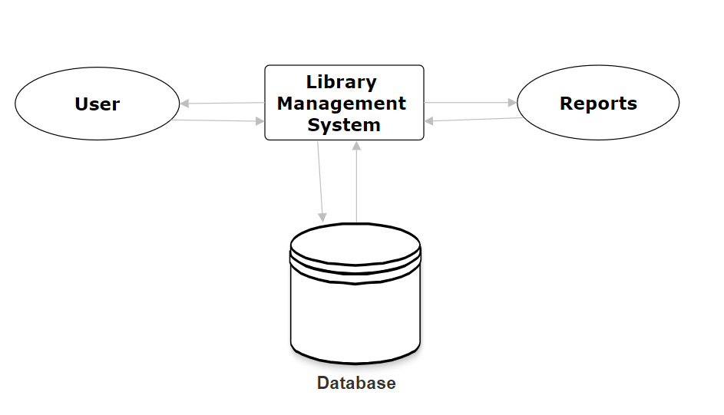

Conclusion:

Library Management System allows the user to store the book details and the customer details. This software package allows storing the details of all the data related to library.

The Library Management System is much more user friendly, faster in operation and easy to manage than the manual one.

Through the use of it, the librarian can manage the whole data of the library in a single database in different tables with a much more security than the traditional way.

The implementation of the system in the organization will considerably reduce data entry, time and also provide readily calculated reports.

Future Scope :

Our web-based application “Library Management System” which provides complete information about Users like Readers, Staff and student. We will add more content on them in future. In our web-based application right now, only Books and Users with their information available .

We will also provide more images in GUI related to our web-based application in future.

We will try to find out more about this topic and add in future. We will try to make this application more attractive so that visitor cannot get bored while using it. We will provide login id to each and every user so that he can access our website from anywhere through login id and password. In future we add some major facilities like Reservation of Book.

References:

https://www.geeksforgeeks.org/library-management-system/

<https://www.javatpoint.com>

https://nevonprojects.com/e-library-project/

THANK YOU